

**MINISTERUL EDUCAȚIEI, CULTURII ȘI CERCETĂRII**

**AL REPUBLICII MOLDOVA**

**Universitatea Tehnică a Moldovei**

**Facultatea Calculatoare, Informatică şi Microelectronică**

**Departamentul Informatică şi Ingineria Sistemelor**

**Raport**

**pentru lucrarea de laborator Nr.7**

***la cursul de “POO”***

Efectuat: Studentul gr. SI-191 **Pavalachi Andrei**

Verificat:  *conf. Univ* **Mititelu V**

**Chișinău – 20****20**

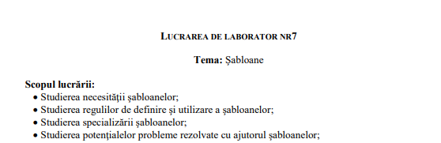

1. **Sarcina lucrării:**

Varinta 6:

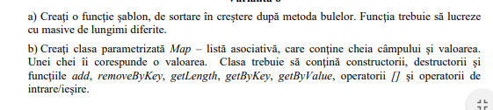

1. **Listingul programului:**

**#include <iostream>**

**#include <vector>**

**template<class T>**

**void bubble_sort(T *arr, int len)**

**{**

**int i, j;**

**for (i = 0; i < len - 1; i++)**

**for (j = 0; j < len - i - 1; j++)**

**if (arr[j] > arr[j + 1])**

**{**

**T tmp = arr[j];**

**arr[j] = arr[j + 1];**

**arr[j + 1] = tmp;**

**}**

**}**

**template<class T1, class T2>**

**class map**

**{**

**public:**

**map()**

**{**

**};**

**map(T1 key, T2 value)**

**{**

**this->key.push_back(key);**

**this->value.push_back(value);**

**}**

**void add(T1 key, T2 value)**

**{**

**this->key.push_back(key);**

**this->value.push_back(value);**

**}**

**void removeByKey(T1 key)**

**{**

**auto it = find(this->key.begin(), this->key.end(), key);**

**if (it != this->key.end())**

**{**

**int index = it - this->key.begin();**

**this->key.erase(index);**

**this->value.erase(index);**

**}**

**}**

**void removeByValue(T2 value)**

**{**

**auto it = find(this->value.begin(), this->value.end(), value);**

**if (it != this->value.end())**

**{**

**int index = it - this->value.begin();**

**this->key.erase(index);**

**this->value.erase(index);**

**}**

**}**

**int getLength()**

**{**

**return (this->key.size());**

**}**

**T2 getByKey(T1 key)**

**{**

**auto it = find(this->key.begin(), this->key.end(), key);**

**int index = 0;**

**if (it != this->key.end())**

**{**

**index = it - this->key.begin();**

**}**

**return (value[index]);**

**}**

**T1 getByValue(T2 value)**

**{**

**auto it = find(this->value.begin(), this->value.end(), value);**

**if (it != this->value.end())**

**{**

**int index = it - this->value.begin();**

**}**

**return (this->value[value]);**

**}**

**T2 operator[](T1 key)**

**{**

**return (this->getByKey(key));**

**}**

**private:**

**std::vector<T1> key;**

**std::vector<T2> value;**

**};**

**int main()**

**{**

**int a[] = { 3, 2, 5, 6, 1, 3 };**

**bubble_sort<int>(a, 3);**

**for (int i = 0; i < 6; i++)**

**std::cout << a[i] << " ";**

**std::cout << std::endl;**

**map<std::string, int> b;**

**b.add("Ion", 4);**

**b.add("Vasilie", 5);**

**std::cout << b.getLength() << std::endl;**

**std::cout << b["Ion"] << std::endl;**

**std::cout << b.getByKey("Vasilie") << std::endl;**

**return (0);**

**}**

1. **Concluzia:**